أسئلة وأجوبة إمتحان اللافقاريات 221 ح
(ورقة إمتحانية كاملة)

كلية: العلوم
قسم: علم الحيوان
المستوى: الثانى
الشعبة: حيوان وكيمياء، بيوتكنولوجى
تاريخ الإمتحان: 2015/ 12/ 26
الممتحنون: د/ جيهان لاشين
د/ داليا سعيد حمزة

Benha University Jan., ‏2016
Faculty of Science 2nd Level Zoology- Chemistry & Biotechnology
Zoology Department Time Allowed: 2 Hrs

INVERTEBRATES 221 Z

Part (1)

I- (a) Complete the following: [10 Mark]

- The gills of the Penaeus fall into three types ……, …… & …….
- The Spermathecae of Earthworm are …….. pairs situated in segments ……… and they receive …………………………….. .
- Suboesophageal ganglion of Scorpion gives off nerves to ........ ............ .
- Coelom in Annelida performs different functions …… ,…….. & …………
5. The blood of ……...... has no respiratory function but it perform other functions such as …… , ……… & ……… .
6. The function of epipodites is ............. while the function of thelycum…………
7. Serial homology means .........................., while autotomy means ..................
8. Respiration of Neries takes place by …….., while in Scorpion takes place by…………. .
9. Clitellum in ………. is permanent while in ……. is temporary, it is help in …………, ………. & ………………
10. In isolated abdominal segment of Penaeus, the exoskeleton composed of six plates ………, ………….., …………..& ……… .

(b) Choose: [6 Mark]

1. The ………. collect waste from the blood and other parts the body.
a) Thelycum b) Green glands
c) Lung -book d) Not a, b, c
2. Which of the following is modified appendage of mesosoma in Scorpion?
a) Maxillae b) Uropodes
c) Pecten d) Pedipalp
3. …………. a transverse plate which makes the two appendages of Cyclops moves together.
a) Antenna b) Maxilla
c) Copula d) Chelicera
4. Which of the following is not a mandibulate?
a) Scorpion b) Scolopendra.
c) Prawn d) Lepas

5. In Nereis, the development is …… through Trochophore larva.
a) Direct b) Sexual
c) Indirect d) Not a ,b &c
6. The body wall is dermo-muscular in ……….
a) Annelida b) Arthropoda
c) Mollusca d) Not a ,b &c
7. Cerebral ganglion of Penaeus gives nerves to:
a) Eyes, antennae & mandible. b) Eyes, antennae &maxilla
c) Eyes, antennae & antennules d) Not a, b &c Function of
8. Arachnids have ………. pairs of walking legs.
a) Four b) Five
c) Three d) Two
9. Scolopendra is Opithogeneate animal this mean:
a) Has posterior anus b) Has two tesis.
c) Has one ovary d) Has posterior genital opening
10. Ventral blood vessel in Earth worm, is the main …………vessel.
a) Collecting b) Contractile
c) Distributing d) Not a, b &c
11. Unlike other annelids polychaetes usually lack:
a) Parapodium b) a coelom
c) Setae d) permanent gonads
12. In Scorpion there are ….... pairs of stigmata .
a) 6 b) 9
c) 4 d) None of these

II -Give a complete account about two only: [8 Marks]
(a) Circulatory system of Penaeus japonicus .
(b) Copulation & formation of Cocoon in Earthworm.
(c) i. Exoskeleton of Arthropoda ii. Digestive system of Hirudo.

Part (2)

- Choose the correct answer: (8 Mark)

1. The inner layer in the shell of a mollusc is composed of _________.
a. Conchiolin. b. Horizontal lamellae of calcium carbonate.
c. Fibers called sponging. d. Vertical arranged crystals of calcium carbonate.
2. In Mollusca, the mantle secretes ___________.
a. exoskeleton. b. mucous. c. saliva. d. none of the previous.
3. In Mollusca, the coelom is
a. absent. b. enlarged. c. reduced. d. None of the previous.
4. In Mollusca, excretion often takes place by
a. diffusion through the skin. b. one coelomic kidney.
c. two coelomic kidneys. d. None of the previous.
5. In chiton, the nervous system is
- primitive and ganglionated. b. primitive and non ganglionated.
c. well developed and ganglionated. d. well developed and non ganglionated.
6. Each sex of the chiton has
- one gonad and one gonoduct. b. two gonads and two gonoducts.
c. one gonad and two gonoducts. d. two gonads and one gonoduct.
7. The desert snail heart consists of
a. one auricle and one ventricle. b. two auricles and one ventricle.
c. one auricle and two ventricles. d. two auricles and two ventricles.
8. Anodonta moves slowly by _________.
- foot. b. tentacles. c. lateral fins. d. all of the previous.
9. The gills of the fresh water clam are responsible for _________.
- respiration and locomotion. b. respiration and food collection.
c. respiration and excretion. d. None of the previous.
10. The nervous system of Sepia is _________.
a. primitive. b. composed of network of unpolarized nerve cells.
c. highly developed. d. None of the previous.
11. The adult sea star is ___________.
a. asymmetrical. b. bilaterally symmetrical.
c. radially symmetrical. d. None of the previous.
12. The larva of the sea star is called ________.
  - bipinaria. b. trochophore. c. glochidium. d. veliger.
13. The nervous system of echinoderms is ___________.
    - primitive. b. ganglionated. c. more advanced. d. none of the previous.
14. In Echinodermata, the anus ________.
a. is absent. b. present in an oral surface. c. present in an aboral surface.
d. All of the above are present in some members of the Echinodermata.
15. Echinodermata are exclusively _________ animals.
a. marinewater. b. freshwater. c. terrestrial. d. All of the previous.
16. The body of Echinodermata is
- diploblastic. b. triploblastic. c. acoelomate. d. segmented.

(تابع بقية الأسئلة بالخلف)

- Write “true” or “false” for each of the following statements with “error correction”: (8 Mark)

- The Mollusca are bilaterally symmetrical.
- The body of Mollusca is consists of three main regions, head; foot and shell.
- In Mollusca, the shell is secreted by the headfoot.
- Mollusca have an "open" circulatory system.
- A Freshwater habitat is only a suitable habitat for members of the Mollusca.
- For gathering food, molluscs have a rasping and scraping organ called a radula.
- In Mollusca, respiration takes place by two gills or through skin.
- The development in Mollusca is often direct.
- The Sea Star larva is radially symmetrical.
- Most reproduction in echinoderms is sexually and external.
- Sea star belongs to class Holothuroidea.
- Echinodermata have well developed excretory system.
- Sea star has four pairs of gonads.
- The coelom of Echinodermata is reduced.
- The digestive system of Sea Star has five pairs of pyloric caeca.
- Sea Urchin belongs to class Echinoidea.

- Complete the table: (8 Mark)

 | Chiton | Eremina | Anodonta | Sepia
Class
Habitat
Radula
Respiration
Excretion
Nervous system
Heart
Sex
Development
Larva

(With best wishes)

Answers

Part (1)
I- (a) Complete the following: [10 Mark]

- The gills of the Penaeus fall into three types Arthrobranchiae, Pleurobranchiae & Podobranchiae.
- The Spermathecae of Earthworm are Two pairs situated in segments 10 &11 and they receive sperm from the other worm.
- Suboesophageal ganglion of Scorpion gives off nerves to all appendages of prosoma, genital operculum ,pectin & two pairs of stigmata in segments 3&4of mesosoma .
- Coelom in Annelida performs different functions provides turgidity , acts as hydraulic skeleton & help in nutrition excretion , respiration.
5. The blood of Scolopendra has no respiratory function but it perform other functions such as transport food, hormones carried about it , water content serves to withstand dessication.
6. The function of epipodites is removing air bubbles attached to the gills, while the function of thelycum act as external seminal receptacle
7. Serial homology means homologous structures modified in different ways to perform different functions while Autotomy means Automatic breaking off an appendage.
8. Respiration of Neries takes place by simple diffusion while in Scorpion takes place by lung book.
9. Clitellum in Earthworm is permanent while in Hirudo is temporary, it is help in secretes cocoon and mucus that assists in the transfer of sperm between individuals, and produces albumen, which serves as a food resources for embryos.
10. In isolated abdominal segment of Penaeus , the exoskeleton composed of six plates tergum , sternum , two pleura & two epimeron

(b) Choose: [6 Mark]

1. b) Green glands 2. c) Pecten 3. c) Copula 4. a) Scorpion 5. c) Indirect 6. a) Annelida 7. c) Eyes, antennae & antennules
8. a) Four 9. d) Has posterior genital opening 10 .c) Distributing
11. d) permanent gonads 12. c) 4

II -Give a complete account about two only: [8 Marks]

(a) Circulatory system of Penaeus japonicus

Open circulatory system.
The body cavity is largely haemocoelic. The heartlies within pericardial sinus. Respiratory pigment is heamoglopin& blood is red. The heart is hexagonal pierced by three pairs of ostia. The blood leaves the heart through 5 arteries anterior & one artery posterior. Ophthalmic to the eyes, 2 Antennary to antennule &antennae,2 hepatic to the digestive gland.
Abdominal artery:
arises posteriorly and splits into :
Superior abdominal artery and Sternal artery. All these arteries branch extensively in the various organs, all the vessels have open ends and communicate with a system of sinuses. The sinuses communicate with the sternal sinus. Sternal sinus sends 18 channels to gills to be aerated, 6 main branchiocardiac open into the heart.
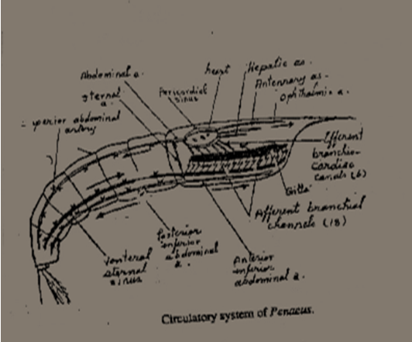

(b) Copulation & formation of Cocoon in Earthworm
The earthworm reproduces sexually throughout most of the year, cross fertilization always occurs. Copulation involves the mutual exchange of spermatozoa between two worms, which then separate and later on form cocoons in which fertilization of the eggs and development of the embryos take place. The two worms appose the ventral surface of their anterior parts and cling to each other by their chaetae, with their heads pointing in opposite directions and the clitellum of each worm lying opposite to the region of the spermathecal pores of the other worm. The spermatozoa are then squeezed out of the male genital openings(segment 15) of each of the two worms and are carried backwards along temporary longitudinal seminal grooves to the region of the clitellum, where they become forced into the spermathecae of the other worm. The two worms then separate.

When the eggs are ripe, the clitellum of each worm secrets a mucous tube around itself, the cocoon, and fills it with albumen secretion from its glands. This cocoon is then forced to glide forwards by muscular contraction of the body behind it. As the cocoon passes over the female genital openings(segment14) few eggs are discharged into it, then as it passes further forwards over the spermathecl pores, it receives some of the spermatozoa which are stored in the spermathecae. Finally the worm slips out of the cocoon, closes it at both ends, and leaves it in the soil.
Fertilization occurs inside the cocoon, and the zygotes develop into young worms which later on escape from the cocoon
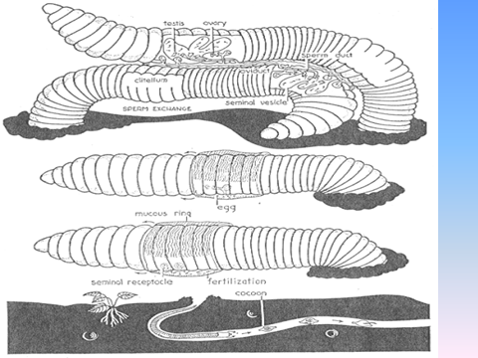

(c) Exoskeleton of Arthropoda
The exoskeleton is composed of chitin. Exoskeleton is composed of three layers, secreted by the epidermis that lies just beneath: A thin, waxy epicuticle containing no chitin. It repels water and keeps terrestrial arthropods from drying out. The thick, hard exocuticle is rich in calcium and provides protection for the inner body parts.
The endocuticle consists of laminated layers of protein and chitin fibers, creating an extremely tough and flexible substance allowing the animal to move freely.
According to the presence of hard exoskeleton in Arthropoda, appear new characters, Reduced coelome , Jointed appendages, Separation of muscles and moulting . The exoskeleton protects the organs against desiccation, act as a point of muscle attachment & protects the animal against predators.

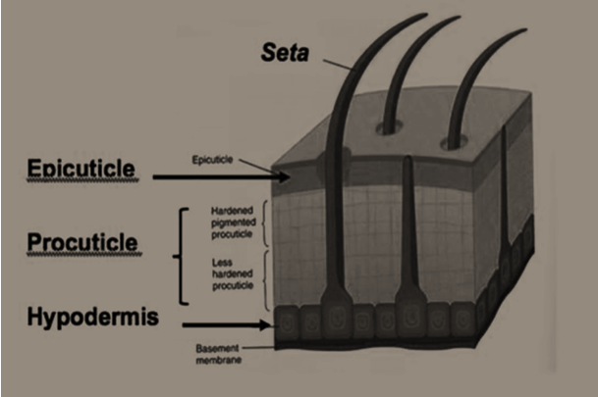

(b) Digestive system of Hirudo
The alimentary canal shows various modifications correlated with the blood sucking habits of this animal. The buccal region. Surrounding the mouth. Encloses 3 serrated chitinous jaws, one dorsal and 2 ventro-laterals. These jaws cause a triradiate wound. Numerous unicellular salivary glands open close to the mouth. They secrete hirudin, a substance which prevents the coagulation of blood while the leech is feeding . It is followed by a highly muscular suctorial pharynx, then a voluminous crop which extends along 11 segment(8-18) and consists of 11 thin-walled wide chambers. Each provided with a pair of lateral pockedts or diverticula. The crop is followed by a small digestive stomach, then a narrow intestine which opens to the exterior by the anus.
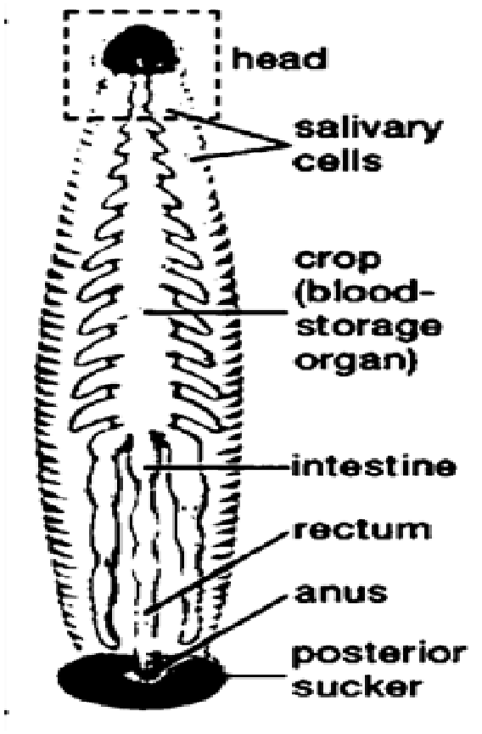

Part (2)
I- Choose the correct answer: (8 Mark)
1. The inner layer in the shell of a mollusc is composed of _________.
d. Vertical arranged crystals of calcium carbonate.
2. In Mollusca, the mantle secretes ___________.
a. exoskeleton.
3. In Mollusca, the coelom is
c. reduced.
4. In Mollusca, excretion often takes place by
c. two coelomic kidneys.
5. In chiton, the nervous system is
b. primitive and non ganglionated.
6. Each sex of the chiton has
c. one gonad and two gonoducts.
7. The desert snail heart consists of
a. one auricle and one ventricle.
8. Anodonta moves slowly by _________.
- foot.
9. The gills of the fresh water clam are responsible for _________.
b. respiration and food collection.
10. The nervous system of Sepia is _________.
c. highly developed.
11. The adult sea star is ___________.
c. radially symmetrical.
12. The larva of the sea star is called ________.
  - bipinaria.
13. The nervous system of echinoderms is ___________.
    - primitive.
14. In Echinodermata, the anus ________.
d. All of the above are present in some members of the Echinodermata.
15. Echinodermata are exclusively _________ animals.
a. marinewater.
16. The body of Echinodermata is
b. triploblastic.

II- Write “true” or “false” for each of the following statements with “error correction”: (8 Mark)

      - The Mollusca are bilaterally symmetrical.
(True)
- The body of Mollusca is consists of three main regions, head; foot and shell.
(False)
The body of Mollusca is consists of three main regions, head;foot and visceral hump.
- In Mollusca, the shell is secreted by the headfoot.
(False)
In Mollusca, the shell is secreted by the mantle.

- Mollusca have an "open" circulatory system.
(True)
- A Freshwater habitat is only a suitable habitat for members of the Mollusca.
(False)
Freshwater, marinewater and terrestrial habitats are suitable habitats for members of the Mollusca.
- For gathering food, molluscs have a rasping and scraping organ called a radula.
(True)
- In Mollusca, respiration takes place by two gills or through skin.
(True)
- The development in Mollusca is often direct.
(False)
The development in Mollusca is often indirect.
- The Sea Star larva is radially symmetrical.
(False)
The Sea Star larva is bilaterally symmetrical.
- Most reproduction in echinoderms is sexually and external.
(True)
- Sea star belongs to class Holothuroidea.
(False)
Sea star belongs to class Asteroidea.
- Echinodermata have well developed excretory system.
(False)
Excretory system is absent in Echinodermata.
- Sea star has four pairs of gonads.
(False)
Sea star has five pairs of gonads.
- The coelom of Echinodermata is reduced.
(False)
The coelom of Echinodermata is large.
- The digestive system of Sea Star has five pairs of pyloric caeca.
(True)
- Sea Urchin belongs to class Echinoidea.
(True)

III- Complete the table: (8 Mark)

 | Chiton | Eremina | Anodonta | Sepia
Class | Polyplacophora | Gastopoda | Bivalvia | Cephalopoda
Habitat | Marine water on rocks | Terrestrial on  desert shrubs | Fresh water in the  mud | Marine water
Radula | Present | Present | Absent | Present
Respiration | By ctenidia | By mantle | By pair of gills | By pair of gills
Excretion | By two U-shaped  kidneys | By one triangular kidney | By two V-shaped kidneys | By two Kidneys
Nervous  System | Primitive and non-ganglionated | Primitive and ganglionated | Primitive and ganglionated | Advanced
Heart | Three chambers, two  auricles and one  ventricle | Two chambers,  one auricle and  one ventricle | Three chambers,  two auricles and  one ventricle | Three chambers,  two auricles and  one ventricle
Sex | Separate | Hermaphrodite | Separate | Separate
Development | Indirect | Direct | Indirect | Direct
Larva | Trochophore | No larval stage | Glochidium | No larval stage

